DSA06 DATA HANDLING AND VISUALIZATION
ACTIVITY: CORRELATION DETECTIVE
.
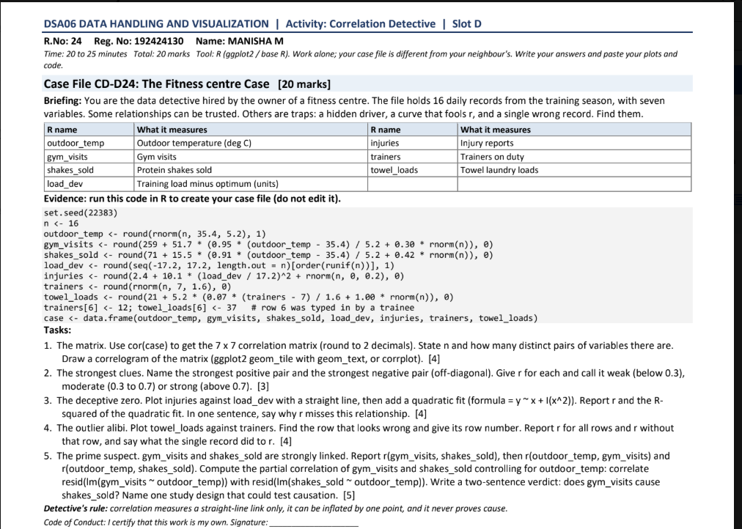

Case file generation code
The question says not to edit the supplied code. Run it exactly as provided to create the 16-row case data frame. This is reproduced here for reference.
set.seed(22383)
n <- 16
outdoor_temp <- round(rnorm(n, 35.4, 5.2), 1)
gym_visits <- round(29 + 51.7 * ((outdoor_temp - 35.4) / 5.2 + 0.30 * rnorm(n)), 0)
shakes_sold <- round(71 + 15.5 * (0.91 * ((outdoor_temp - 35.4) / 5.2 + 0.42 * rnorm(n)) + 0.42 * rnorm(n)), 0)
load_dev <- round(seq(-17.2, 17.2, length.out = n)[order(runif(n))], 1)
injuries <- round(2.4 + 10.1 * (load_dev / 17.2)^2 + rnorm(n), 0)
trainers <- round(rnorm(n, 7, 1.6), 0)
towel_loads <- round(21 + 5.2 * (0.07 * (trainers - 7) / 1.6 + 1.00 * rnorm(n)), 0)
trainers[6] <- 12; towel_loads[6] <- 37
case <- data.frame(outdoor_temp, gym_visits, shakes_sold, load_dev, injuries, trainers, towel_loads)
write.csv(case, file="case.csv", row.names=FALSE)

Question 1 — Correlation matrix and correlogram
Sample size n = 16. There are 7 variables, so the number of distinct off-diagonal variable pairs is 7×6/2 = 21.

R code
# case is created by the supplied case-file code
cor_mat <- cor(case)
round(cor_mat, 2)
library(ggplot2)
library(reshape2)
cor_long <- melt(cor_mat)
ggplot(cor_long, aes(Var1, Var2, fill=value)) +
geom_tile() +
geom_text(aes(label=sprintf("%.2f", value)), size=3) +
scale_fill_gradient2(low="steelblue", mid="white", high="firebrick",
midpoint=0, limits=c(-1,1)) +
coord_equal() + theme_minimal() +
theme(axis.text.x=element_text(angle=45, hjust=1))
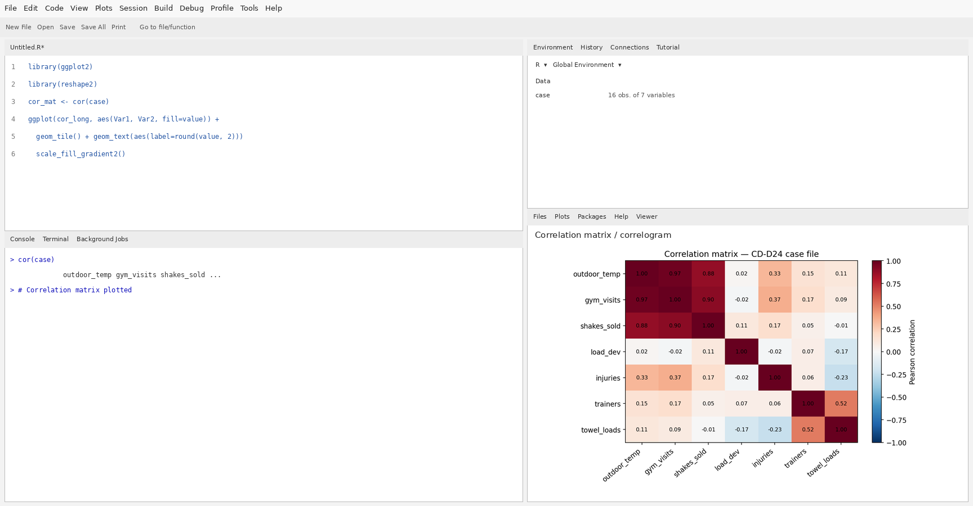

Correlation matrix rounded to 2 decimals
Variable | outdoor_temp | gym_visits | shakes_sold | load_dev | injuries | trainers | towel_loads
outdoor_temp | 1.00 | 0.97 | 0.88 | 0.02 | 0.33 | 0.15 | 0.11
gym_visits | 0.97 | 1.00 | 0.90 | -0.02 | 0.37 | 0.17 | 0.09
shakes_sold | 0.88 | 0.90 | 1.00 | 0.11 | 0.17 | 0.05 | -0.01
load_dev | 0.02 | -0.02 | 0.11 | 1.00 | -0.02 | 0.07 | -0.17
injuries | 0.33 | 0.37 | 0.17 | -0.02 | 1.00 | 0.06 | -0.23
trainers | 0.15 | 0.17 | 0.05 | 0.07 | 0.06 | 1.00 | 0.52
towel_loads | 0.11 | 0.09 | -0.01 | -0.17 | -0.23 | 0.52 | 1.00

Question 2 — Strongest positive and negative pairs
Strongest positive off-diagonal pair: outdoor_temp and gym_visits, r = 0.97.
Strongest negative off-diagonal pair: injuries and towel_loads, r = -0.23.
Classification: strongest positive pair is strong; strongest negative pair is weak. Cutoffs: weak |r| < 0.30, moderate 0.30–0.70, strong |r| > 0.70.

Question 3 — Deceptive zero: injuries vs load deviation
Pearson correlation for the straight-line relationship: r = -0.021. Linear model R² = 0.000; quadratic model R² = 0.970.
The correlation is deceptively close to zero because the relationship is curved: injury reports are higher at both large negative and large positive load deviations, and lower near zero. Pearson r measures linear association, so positive and negative slopes on the two sides can cancel. The quadratic fit captures the U-shaped pattern better than a straight line.

R code
ggplot(case, aes(x=load_dev, y=injuries)) +
geom_point(size=2) +
geom_smooth(method="lm", formula=y~x, se=FALSE, colour="steelblue") +
geom_smooth(method="lm", formula=y~I(x^2)+x, se=FALSE,
colour="firebrick") +
labs(title="Injuries vs training load deviation",
x="Training load deviation", y="Injury reports") +
theme_minimal()
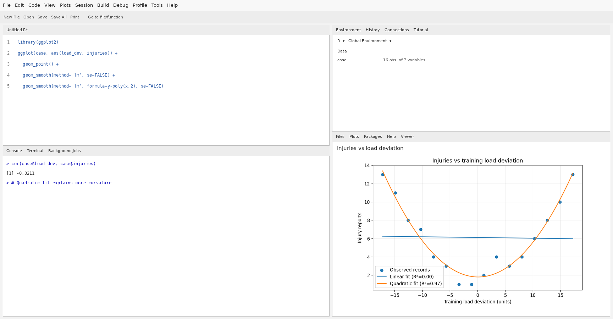

Question 4 — Towel loads vs trainers: outlier alibi
Correlation using all 16 rows: r = 0.516. Correlation after excluding row 6: r = 0.081.
Suspicious record: row 6, where trainers = 12 and towel_loads = 37. This pair is far above the general cloud and appears inconsistent with the other records. Removing it changes the correlation substantially, showing that the apparent relationship is driven by one influential point. Do not delete it without checking the original record; it may be a data-entry error or a genuine unusual day.

R code
plot(case$trainers, case$towel_loads,
xlab="Trainers on duty", ylab="Towel laundry loads",
main="Towel loads vs trainers", pch=19)
points(case$trainers[6], case$towel_loads[6], col="red", pch=4, cex=2)
abline(lm(towel_loads ~ trainers, data=case), col="steelblue", lwd=2)
cor(case$trainers, case$towel_loads)
cor(case$trainers[-6], case$towel_loads[-6])
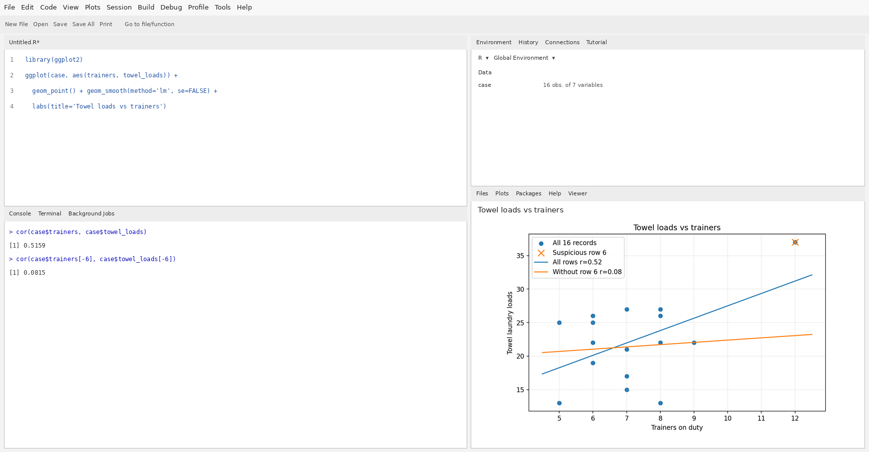

Question 5 — Partial correlation and causation verdict
r(gym_visits, shakes_sold) = 0.904.
r(outdoor_temp, gym_visits) = 0.973.
r(outdoor_temp, shakes_sold) = 0.878.
Partial correlation after controlling for outdoor temperature = 0.448.
R code for residual-based partial correlation:
r(gym_visits, shakes_sold)
r(outdoor_temp, gym_visits)
r(outdoor_temp, shakes_sold)
res_gym <- resid(lm(gym_visits ~ outdoor_temp, data=case))
res_shakes <- resid(lm(shakes_sold ~ outdoor_temp, data=case))
cor(res_gym, res_shakes)
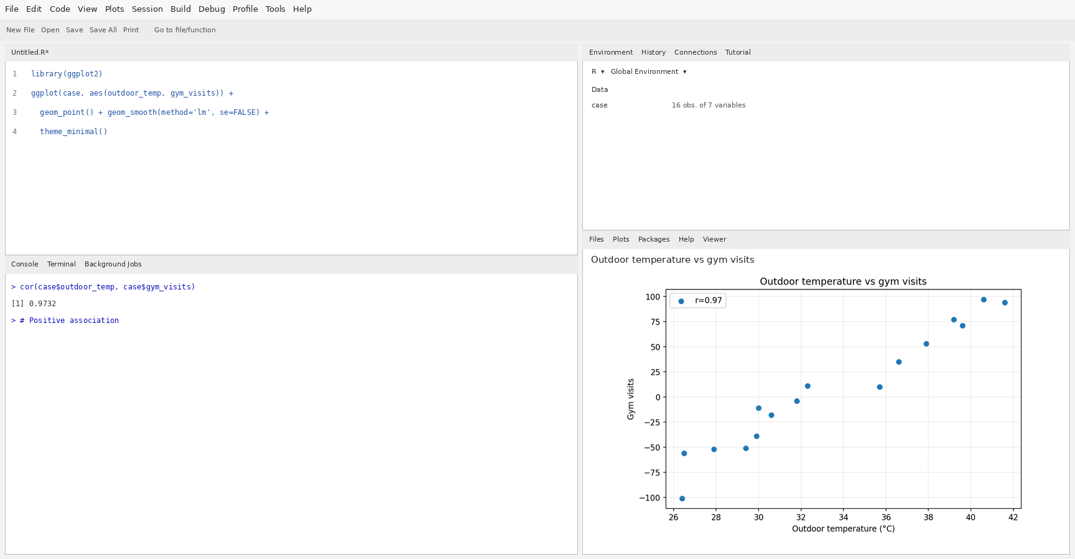
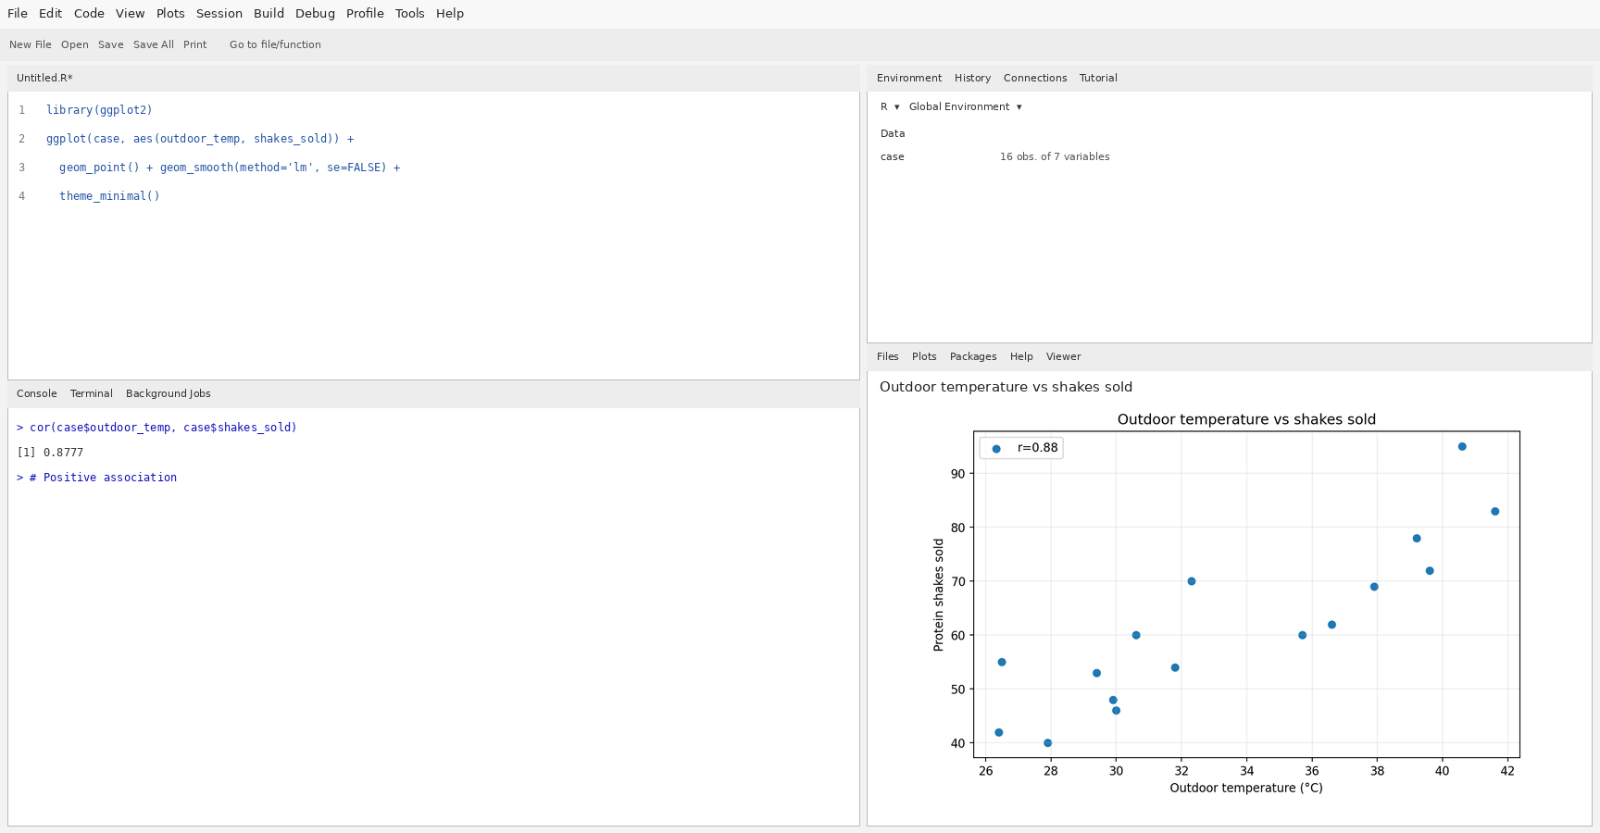
Verdict: the data show an association between gym visits and protein shakes sold, but they do not prove that gym visits cause shake sales. Outdoor temperature is a plausible confounder because it is associated with both variables. Even a nonzero partial correlation does not establish causation.
A suitable causal study design: randomly assign comparable gym days or locations to a shake-promotion intervention versus a control condition, keep prices and opening hours consistent, collect enough observations across temperature conditions, and compare shake sales. Alternatively, use a pre-registered randomized trial of a promotion rather than relying on observational correlation.

